**Python Final Project**

**Group I**

**Formula One Text Based Manager**

# Bano Qabil 4.0

# Fundamentals of Computer Programming

# Final Assignment

# Group Members:

# 

# 

# 

Fardan Bin Khalid

Arhum

Muhammad Abeer

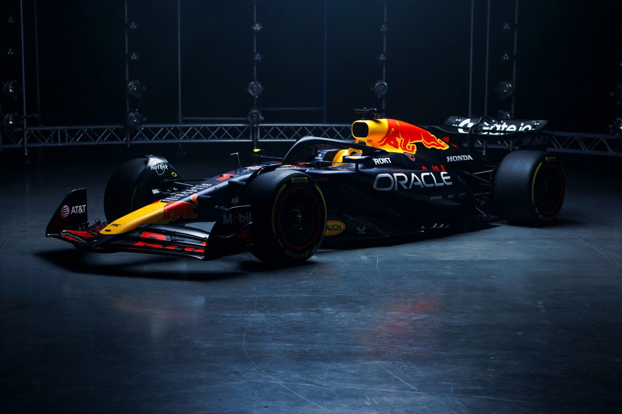Siddique

***Formula One Manager Text Based***

Documentation For The Unofficial Tex-Based Fomula One Manager Game (built in python):

**What the Program does:**

When you run the program, after a few seconds the command prompt opens and asks you to name your team. The main menu of the game opens and greets you as the team principal of the team whose name you entered. In the main menu, there are 5 options:

1. Start Race

Selecting this option will take you to the race whose results will be calculated using this formula:

Score: (Sum of both drivers skill + Car’s Power)/2

And the results will be sorted according to decreasing score after which points and money will be distributed according to the order of positions, the entire list of teams respective of their postion will be printed at the end. All these operations are done using a single function

1. Marketplace

Purchase drivers and upgrades for your car over here

1. Train Driver

Spend money to increase driver’s skill

1. Show Standings

Will show where each team and driver stands so far this season in their respective championship

1. Quit

Exits the game

Each option is using a function that does everything. There’s also a function present to tell the user about invalid input. Cars, Teams etc. have their own classes. After 24 races are complete you’ll see end of the season results.

The blueprint I made for this program is present on the next page.

Flowchart

